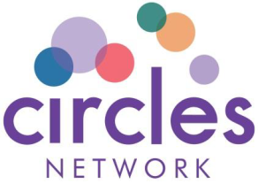
Circles Network Mid-Summer Ball

Saturday 22nd June 2019
Coventry Rugby Club, 4401 Butts Rd, Coventry CV1 3GE

BOOKING FORM

Personal Details
Name:
Organisation (if applicable):
Address:
Telephone:
Email:

Booking Details
Please indicate no. of
seats/tables
Early Bird* Seat: £40 per seat
Early Bird* Table** (10 seats) - £400
* all bookings for 'Early bird' rate must be completed and paid in full by 15th May 2019
From the 15th May 2019 the following prices will apply:
Seat - £45 per seat
Table** - £450 for Table of 10
**for table and multiple seat bookings please list the names of guests over the page

Dietary Requirements (if applicable)

Payment Details
Payment can be made by cheque - made payable to Circles Network or by cash in person at our Head Office: Circles Network, The Penthouse, Coventry Road, Cawston, Rugby. CV23 9JP
Tel: 01788 816672

Circles Network Mid-Summer Ball
22nd June 2019

For Table Bookings please list the names of guests who will be attending below:

Name Dietary Requirements

1.
2.
3.
4.
5.
6.
7.
8.
9.
10.

Hotel Special Rate

The Ramada Hotel Coventry is offering a room only rate of £65 for the evening of 22nd June for any guests wishing to stay overnight after the Ball.

If you wish to take advantage of this special rate you will need to book direct with the hotel. This offer does not apply through any third party booking sites.

Ramada Hotel
The, Butts
Coventry
CV1 3GG
Tel: 024 7623 8110

Please Quote 'Circles Network Ball' when making your booking

Thank you for your support
Circles Network

