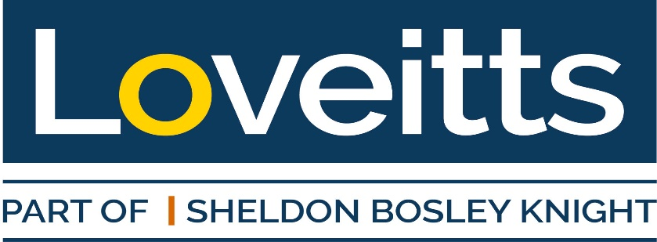

Charity Quiz Night – Booking Form

Thursday 23rd October 2025
Sky Blue Tavern, Hertford Place, Coventry, CV1 3JZ

5.30 p.m. for 6.00 p.m. start

Company Name
Team Name
Number of Attendees
Any dietary requirements?

I/We will transfer the sum of £25 per person to Sheldon Bosley Knight Ltd.
Sort Code: 40-43-19. Account Number: 92228246

Please quote Quiz/your company name

Once completed, please return this form to Philippa.barlow@loveitts.co.uk

We look forward to seeing you there

